Task D:
We create dictionary of attributes, which is collected from internet database and of words in data that reflect attributes. Those attributes saved as an Excel file, in which the first sheet is the attributes name and others are the detail of each attributes. Then we loop every word in the raw data and match it with the attribute dictionary, counting the times it appears. Finally, we get the top 5 attributes mentioned most frequently. They are Registration indicator(e.g. second-hands), Price, Seat(e.g. Number), Engine and millage.

Based on the top 5 brands we get on Task A, we find the following relations:
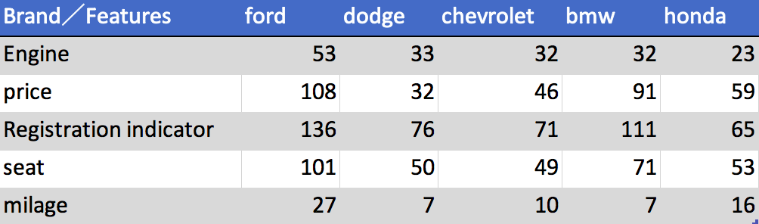

We find that price has been mentioned most between Ford and BMW. Apparently, Ford and BMW aim on separate niche market, which means ford are more affordable for general and BMW targets the people with higher income. The conclusion is lower-price strategy is not always the best choice. The brands should have different price strategies based on segmentation so that they can make themselves distinctive in the market. Moreover, price is obvious one of the most important motivators for people to choose a car. For brands like Ford, they can take advantage of price motivation. And for brands like BMW, they can improve the performance of cars and keep the price unchanged.

